PET TAGS GET A DIGITAL UPGRADE IN (COMMUNITY NAME)
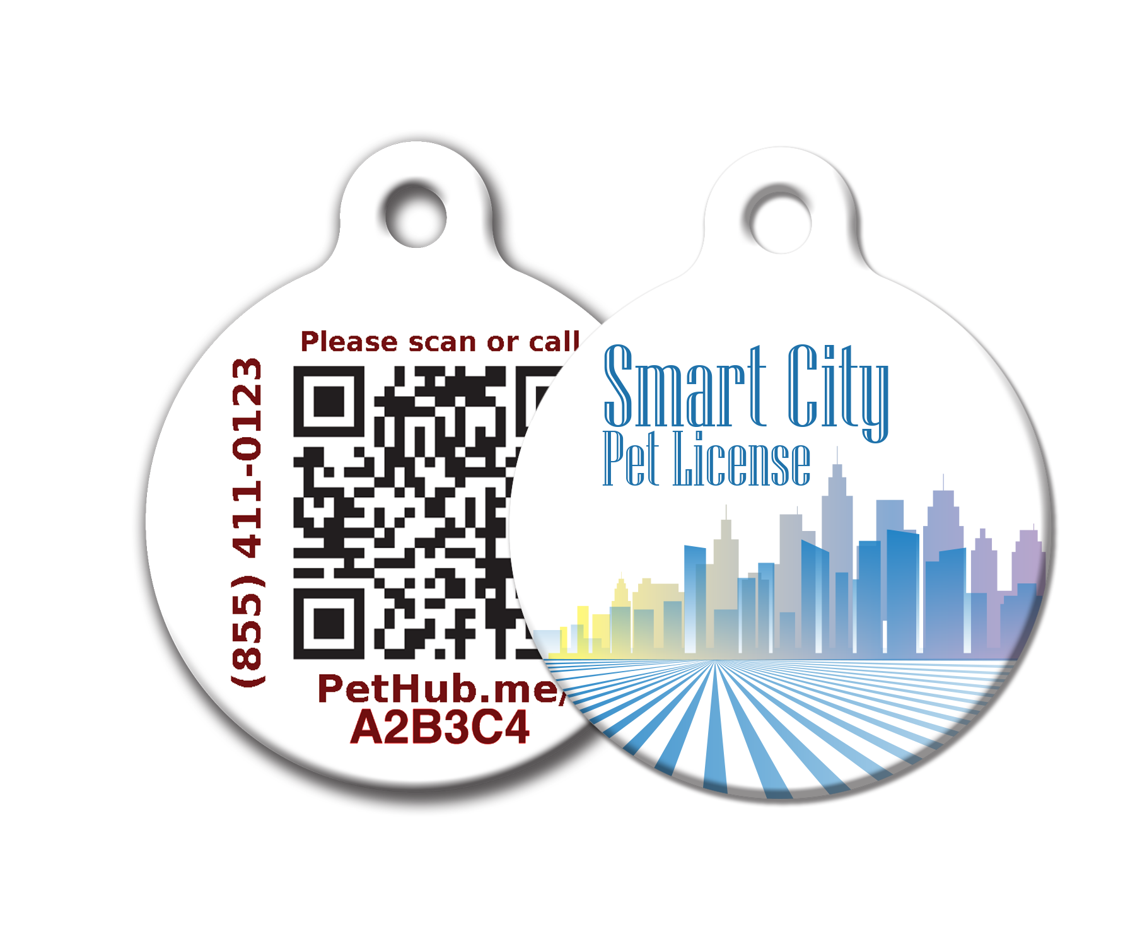
(Client Name) has teamed up with PetHub to offer a new smart ID tag for pets. This new tag provides an extra layer of protection for your pet. You have the ability to create a free online account at PetHub.com and link your tag to your pet's profile through the QR code.

If your pet goes missing and someone finds your pet wearing this tag, the finder can use a smartphone's camera to scan the QR code, view the contact info on your pet's profile, and immediately contact you or someone on your trusted list in order to reunite your pet with you. Your account is safe and secure because you control what information in your pet's profile is visible and what is not.

If the finder does not have a smartphone or does not know how to scan a QR code, there are two other ways. First, the finder can call the phone numbers printed on the tag. After the finder provides the license number, we'll connect you to the finder. Second, the finder can go to PetHub’s website (also printed on the tag), enter the license number, and view your contact info.

With each tag, you have access to PetHub’s FREE Basic Membership . . .
- Online Storage of Your Information – Enter your contact information and your pet’s information into your PetHub account and link your account to your pet’s license number
- Lost Pet Call Center – PetHub's Pet Hotline is staffed 24-hours-a-day/7-days-a-week by humans, not an automated computer
- Lost Pet Poster – Ability to create a lost-pet poster for printing and sharing
- Pet Resource – PetHub’s website offers over 500 searchable articles to help you raise and nurture your pet

Or, upgrade to PetHub’s Premium Membership and receive additional benefits . . .
- Community Alerts – When you report your pet as “missing” on PetHub’s website, PetHub will send a virtual “Lost Pet” notification to local shelters, rescue groups, vet offices, pet professionals, and the PetHub community
- Tag Scan Notification – If someone finds your pet and scans the QR code on the tag, you’ll be notified with text and/or email alerts
- Social Sharing – Have your lost-pet poster shared on social media to spread the word even faster
- Discounts – Receive special offers from PetHub’s partners

To learn more about how to get our next generation tags for your pet:

Visit: (Website)
Call: (Phone Number)
Stop by: (Tag Distribution Address)

PRESS RELEASE WORKSHEET

Identify the various press outlets in your area to get the word out about your new tag program!

Media Type  (Radio, Television, Print, etc.) | Media Company | Contact Info

