OUR PETS ARE RECEIVING AN UPGRADE!

[Agency Name] has teamed up with PetHub to offer a new digital ID tag for pets. This new tag provides an extra layer of protection for pets in our community. Pet parents have the ability to create a free online account at PetHub.com and link the tag to their pet's profile through the QR code.

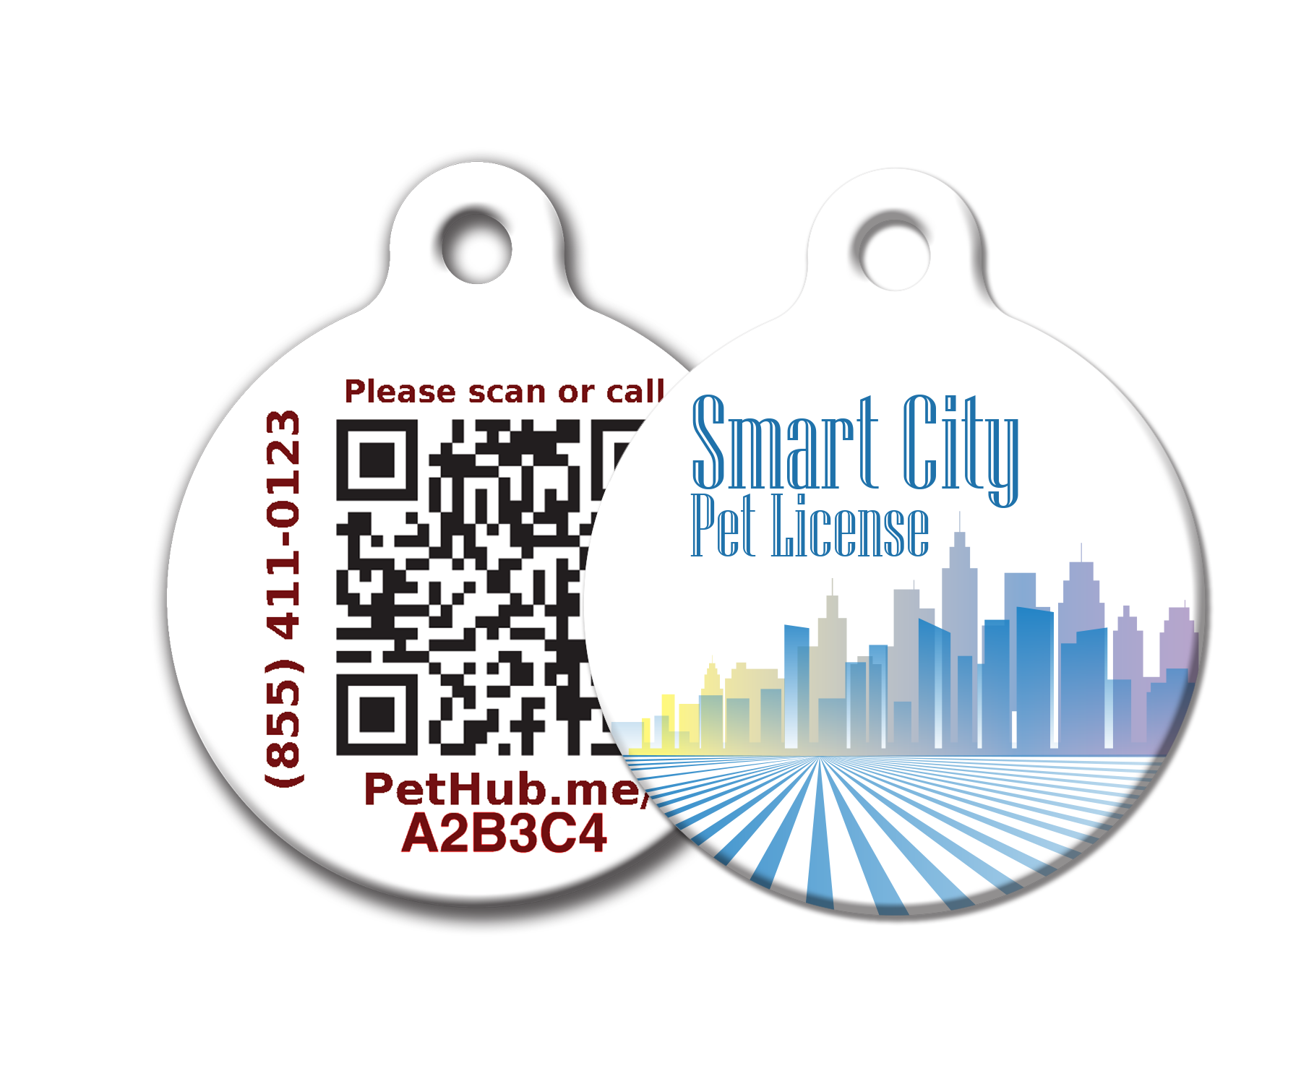
If a pet goes missing and someone finds the pet wearing this tag, the finder can use a smartphone's camera to scan the QR code, view the contact info on the pet's profile, and immediately contact the pet parent or someone on their trusted list in order to reunite the pet with their family. The pet parent controls what information in the pet's profile is visible and what is not.

In the coming weeks you will be receiving more information about how the program works, as well as the benefits to you, our pets, and our community.

Stay tuned!

